Subject | 50/70 MHz contest categories
Society | IARU Region 1 | Country: | N/A
Committee: | C5 | Paper number: | NS20_C5_25
Author: | Alessandro Carletti, IV3KKW Contest WG Chairman

Abstract :

During the last Vienna Interim Meeting 2019 on C5 session it has been presented the VIE19 C5-019 document by ARI.

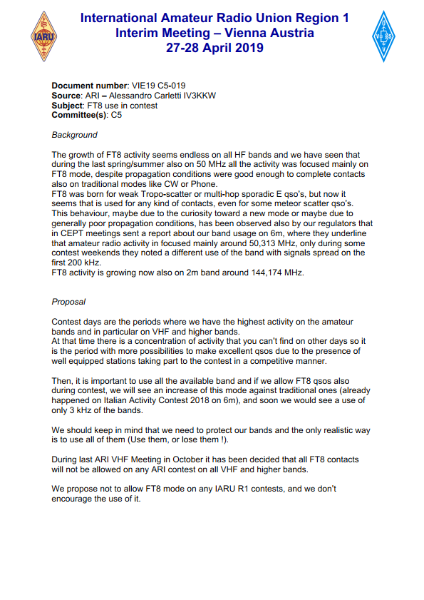

After a discussion with the representatives in Vienna, it has been decided with to carry the handling of FT8 in contests to CWG (VIE19_C5_Rec_11).

Proposal :

The C5 Contest Working Group after discussing it, come to the following decision:

In 2017 it has been conducted a survey among the contesters and at that time FT8 and FT4 modes were still at the beginning of their popularity.
After three years these fast MGM modes became very popular among the amateur radio community and their use in contest, although still not so popular, demonstrate that is not compatible with traditional SSB/CW modes.
For these reasons the C5CWG decided to modify the categories in the IARU R1 50/70 MHz starting from the 2021 edition, in the following way :

SOP without MGM (only CW/SSB)
MOP without MGM (only CW/SSB)

SOP with MGM (CW/SSB/MGM)
MOP with MGM (CW/SSB/MGM)

6H with MGM (CW/SSB/MGM)

And amend the VHF Handbook Paragraph 1.5.1 in this way :

The contests shall comprise the following sections for:

• 50 MHz band:
o SINGLE (SO): single operator entries without MGM (only CW/SSB)
o MULTI (MO): multi operator entries without MGM (only CW/SSB)
o SINGLE (SO-MGM): single operator entries with MGM (CW/SSB/MGM)
o MULTI (MO-MGM): multi operator entries with MGM (CW/SSB/MGM)
o 6HOURS (6H): 6 hours entries (CW/SSB/MGM)

• 70 MHz band:
o SINGLE (SO): single operator entries without MGM (only CW/SSB)
o MULTI (MO): multi operator entries without MGM (only CW/SSB)
o SINGLE (SO-MGM): single operator entries with MGM (CW/SSB/MGM)
o MULTI (MO-MGM): multi operator entries with MGM (CW/SSB/MGM)

