Subject | Report from the Region 1 Satellite Coordinator July 2020
Society | IARU Region 1 | Country: | N/A
Committee: | C5 | Paper number: | NS20_C5_04
Author: | Graham Shirville, G3VZV

Current satellites
There are currently twenty two OSCAR satellites, all except QO-100, in low earth orbit carrying amateur radio voice transponders:
AO7 – Linear transponders – launched in 1974
FO29 - Linear transponder
SO50 – FM transponder
AO73/FUNcube-1 - Linear transponder and educational telemetry
IO86 /LapanA2 - FM transponder
LilacSat-1 - FM transponder
LilacSat-2 - FM transponder (not available in Region 1)
EO88/Nayif - Linear transponder and educational telemetry
XW2A - Linear transponder
XW2B - Linear transponder
XW-2C - Linear transponder
XW-2D - Linear transponder
XW-2F - Linear transponder
CAS-4A - Linear transponder
CAS-4-B - Linear transponder
CAS -6 - Linear transponder
RS44 - Linear transponder
AO91 - FM transponder
AO92/Fox1D - FM transponder with telemetry for educational outreach and L band uplink
JO97/JY1SaT - Linear transponder with educational telemetry and SSDV images
QO100/ Es’hail-2 - Linear transponders in geostationary orbit (see below)
PO101 -FM transponder
There are also a large number of satellites with digital and APRS capability including the ARISS payload on the ISS.
To identify currently available Oscar satellites visit https://www.amsat.org/status/
Other active satellites
In addition to the above spacecraft, there are more than 100, currently active, other satellites which use downlink frequencies within the amateur satellite service allocations. These are generally using the145 MHz and/or 435 MHz bands. These have a variety of functions and their current status can be checked at http://www.dk3wn.info/p/?page_id=29535
Of these, some twenty, although appearing to be operating in the amateur satellite service, have never requested frequency coordination from the IARU. They do not make their telemetry details publicly available and this is in contravention of the Radio Regs.
Additionally, there are a number of missions, which, although they have gone through the IARU frequency coordination process have also not released their telemetry details.

Planned transponder satellite projects

There are numerous FM and linear transponder missions currently under construction including the Tevel project for eight identical 1U CubeSats with FM transponders from the Herzliya Science Center in Israel.
QO100 - EsHail-2
This is a Geostationary Spacecraft at located at 25.8 degrees east and carries two amateur transponders. They will both use 2.4GHz for uplink and 10GHz for downlinks. It was launched in November 2018 and commissioning was completed in the Spring of 2019.
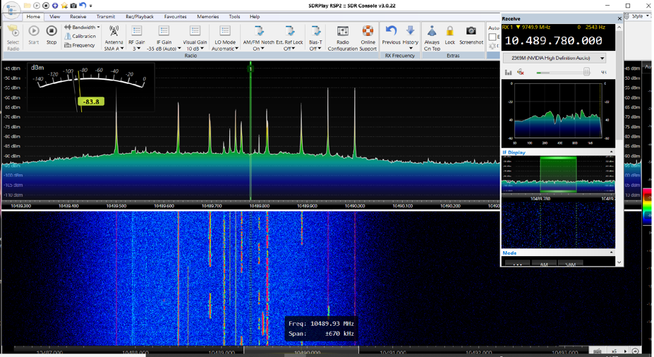
The NB (narrow band) transponder has recently been enabled for a 500kHz bandwidth which will allow even more simultaneous QSOs to take place. All modes are acceptable on this transponder but must not exceed 2.7kHz bandwidth.

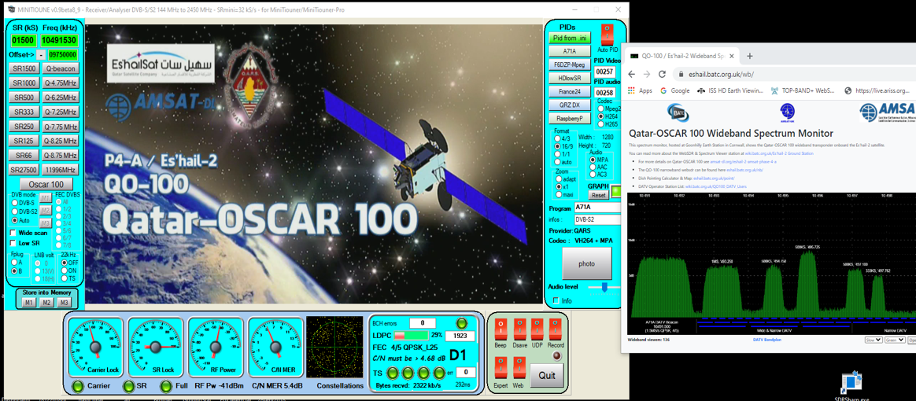
The WB (wide band) transponder is intended for all types of experiments and is currently the centre for much development and testing of new Digital ATV techniques. These include enhanced modulation techniques to obtain quality video with smaller bandwidths.
Both transponders have broad beam antennas to provide full coverage over more than one third of the earth’s surface centered over Africa.
This 24/7 coverage of more than 1/3rd of the globe requires operators to use the transponders responsibly. Bandplans have been developed and “Good operating practices” defined. Generally experience has been good but some non-complaint signals have been observed and there are a number of automatic remote stations being detected. These activities deprecated by AMSAT-DL, QARS and the Eshailsat company.
All IARU member societies within the footprint, are kindly asked to give maximum publicity to the details included here https://amsat-dl.org/p4-a-nb-transponder-bandplan-and-operating-guidelines for the narrowband transponder and here https://amsat-dl.org/p4-a-wb-transponder-bandplan-and-operating-guidelines for the DATV/wideband transponder.
As expected, this mission has created a welcome step change in the development of hardware for, and the level of amateur activity on, both our 2.4 GHz and 10.45 GHz allocations. Many new hardware developments have been undertaken by both individual radio amateurs and specialist suppliers. This development has included new transverters, new PAs, new dual band antennas – including the famous POTY, plus modifications for enhanced stability LNBs. SDR software, such as SDR Console, has also been considerably enhanced to enable Lime and Pluto SDRs to be used for both transmit and receive.
CubeSats
There continues to be a considerable number of CubeSats missions being developed. It is expected that a majority of this volume will be parts of commercial constellations that will use frequencies outside the amateur satellite service spectrum. The number of CubeSats being developed by Universities and similar organisations is expected to be stable over the coming months.
At WRC-19 the ITU agreed a new alternative and simplified regulatory regime for non-GSO satellite systems with short duration missions (<3 years) not subject to coordination. They also identified the VHF bands 137-138 MHz and 148-149.9 MHz for TCM links for these missions. The impact of this decision in relation to the amateur satellite service remains to be seen.

Frequency Coordination
The IARU Frequency Coordination Panel has continued to be very active and is working to ensure that all satellite projects, which are intending to use frequencies in the amateur satellite service, are compliant with the requirements for such use.
Several missions have recently been declined as they cannot demonstrate that they meet the requirements in Art 25 section II of the Radio Regulations. It is hoped that IARU will transmit a more public message in this regard in an effort to reduce these occurrences.
The Frequency Coordination request form has recently been updated and it is hoped to take this online in the future.
Full details of all satellite projects about which the Coordination Panel is aware can be found at http://www.amsat.org.uk/iaru/ and information about the Coordination process itself is available at
https://www.iaru.org/on-the-air/satellites/

Education Outreach
FUNcube-1 (now more than 6 ½ years old!), Nayif-1 and JY1Sat continue to provide telemetry for educational outreach for schools and colleges and a simple omni-directional 145MHz antenna and SDR dongle are all that is required for satisfactory reception. Simple, Windows based, decoders and user interfaces are available for free download.
More than 1200 stations around the world have been submitting the telemetry data that they have received to the central Data Warehouses.
Recent developments have included the installation of a simple station in Antarctica at the Neumayr III station. It uses a simple whip antenna, a FUNcube Dongle and a Raspberry Pi based decoder. The Linux based code for the Rpi has also been released for general use.
The FOX CubeSat programme from AMSAT-NA also provides educational outreach opportunities and is compatible with the FUNcube type receiver systems.

The International Space Station
The ARISS team remain challenged by the equipment failure in the Columbus Module but have continued to organise a large number of contacts between the astronauts and schools using both 145MHz and 435 MHz bands from the Russian module
At the time of writing a new set of equipment called the IORS (InterOperable Radio System) has been delivered to the Station and is awaiting commissioning. This will enable operations using a Kenwood TMD710 to take place from the Columbus module and for cross-band FM transponder operations, including possible 1260 MHz uplinks, to re-commence. It is hoped this will be enabled sometime later in 2020 and further sets of IORS equipment are being manifested for future launches to ensure redundancy. The equipment for the HamTV failed and the hardware was returned to earth for repair in 2019. It is presently waiting for final re-certification before being sent back up to space. Again, it is hoped this will take place before the end of 2020 and work continues on the development of a Video identifier module and a Mk2 HamTV system’
Deeper space activities
Although the majority of amateur satellites continue to operate from low earth orbit, as mentioned above, they have recently been joined by QO100/Eshail-2 in geostationary orbit.
The ARISS International team presently working on the development of an amateur radio system to mounted on the outside of the Lunar Gateway Mission modules. Lunar Gateway is planned to operate in a highly elliptical HALO orbit around the moon and is not expected to be crewed on a continuous basis. The current intention is to fly a low data rate system on 435 MHz and a more sophisticated, digital, transponder using 5.6 GHz for uplinks and 10.45 GHz for downlinks. Link budget simulations baseline a ground setup using a 1.2 metre dish.
Graham Shirville G3VZV
July 2020

